Read Me

Question 1 : GradientDescent TwoExams

<https://www.kaggle.com/muditr97/assignment-3-twoexams?scriptVersionId=11543381>

Question 2 : GradientDescent MicroChip

<https://www.kaggle.com/muditr97/assignment-3-microchip?scriptVersionId=11543325>

Data Set:   
 1. TwoExams

2. MicroChip

The Assignment where done on Jupyter Notebook  
FileName for GradientDescent TwoExams **: ICM2015502__Assignment_3_GradientDescent_TwoExams.ipynb**  
FileName for Gradient Descent MicroChip : **ICM2015502__Assignment_3_GradientDescent_MicroChip.ipynb**

Open the file which ( is public ) add this to jupyter Notebook, Data set Name : “TwoExams “ and run the code, for question 1.

Open the file which ( is public ) add this to jupyter Notebook, Data set Name : “MicroChip “ and run the code, for question 2.   
It will produce the squared error value for Gradient Descent Algorithm for TwoExams and MicroChip data sets.

Libraries used :

1. NumPy
2. SciPy
3. Pandas
4. Os
5. Sklearn
6. matplotlib

Analysis for Assignment for Logistic Regression

Two Exams data :

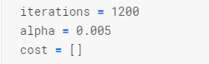  
In this we have considered 1200 iterations, Learning Rate to be 0.005 for the Analysis.

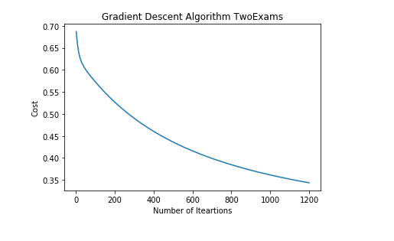

This Graph shows the relationship for the number of Iterations and Cost.



The squared error for TwoExam data for 30-70 Test_train Split is mentioned above.

MicroChip Data:

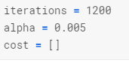

In this we have considered 1200 iterations, Learning Rate to be 0.005 for the Analysis.

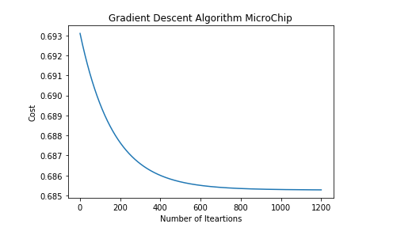

In this we can observe a curve that is more detailed and is plotted for the relationship of number of Iterations to the cost.

The mean squared error for the data set for the train test split is mentioned below

